КЕНДЫБАЕАВ ДАНА

**create database** lab4;  
  
**create table** Warehouses(  
 **code int**,  
 **location varchar**(255),  
 **capacity int**);  
**create table** Boxes(  
 **code char**(4),  
 **contents varchar**(255),  
 **value real**,  
 **warehouse int**);  
  
 **INSERT INTO** Warehouses(**Code**,**Location**,**Capacity**) **VALUES**(1,**'Chicago'**,3),  
 (2,**'Chicago'**,4),  
 (3,**'New York'**,7),  
 (4,**'Los Angeles'**,2),  
 (5,**'San Francisco'**,8);  
  
 **INSERT INTO** Boxes(**Code**,**Contents**,**Value**,**Warehouse**) **VALUES**(**'0MN7'**,**'Rocks'**,180,3),  
 (**'4H8P'**,**'Rocks'**,250,1),  
 (**'4RT3'**,**'Scissors'**,190,4),  
 (**'7G3H'**,**'Rocks'**,200,1),  
 (**'8JN6'**,**'Papers'**,75,1),  
 (**'8Y6U'**,**'Papers'**,50,3),  
 (**'9J6F'**,**'Papers'**,175,2),  
 (**'LL08'**,**'Rocks'**,140,4),  
 (**'P0H6'**,**'Scissors'**,125,1),  
 (**'P2T6'**,**'Scissors'**,150,2),  
 (**'TU55'**,**'Papers'**,90,5);  
*-- 4***select** *\** **from** Warehouses **where location** = **'Chicago'**;  
*-- 5***select** *\** **from** Boxes **where value** > 140 **and value** <= 200;  
*-- 6***select warehouse**, *count*(**distinct contents**) **from** Boxes **group by warehouse**;  
*-- 7***select distinct warehouse from** boxes **where contents** = **'Rocks' and value** < 220;  
*-- 8***update** Boxes **set value** = Boxes.**value** * 1.2 **from** Warehouses **inner join** Boxes B **on** Warehouses.**code** = B.**warehouse  
 where** Boxes.**contents** = **'Papers' and** Warehouses.**code** = Boxes.**warehouse and** (Warehouses.**location** = **'San Francisco' or** Warehouses.**location** = **'New York'**);  
*-- 9***update** Boxes **set value** = **value** / 2 **where contents** = **'Scissors' and** *cast*(**value as int**) % 2 = 0;  
**update** Boxes **set value** = **value** / 5 **from** Warehouses **where location** = **'Chicago' and contents** = **'Papers' and** *cast*(**value as int**) % 2 != 0;  
*-- 10***select** b.**code from** Boxes **as** b **inner join** Warehouses **as w on** b.**warehouse** = **w**.**code where location like '%o' and capacity** > 3;  
*-- 11***select distinct contents**, **warehouse from** Boxes **order by warehouse**;  
*-- 12***SELECT DISTINCT** Boxes.**code**, Boxes.**contents**,Boxes.**value FROM** Boxes, Warehouses  
**WHERE** Boxes.**warehouse** = Warehouses.**code and** Warehouses.**location** != **'Chicago'  
ORDER BY** Boxes.**value DESC  
OFFSET** 1  
**LIMIT** 1;  
*-- 13***SELECT DISTINCT value FROM** Boxes  
**WHERE** *cast*(**value as int**) % 3 = 0  
**ORDER BY value  
OFFSET** 2  
**LIMIT** 1;

#4

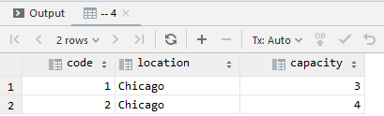

#5

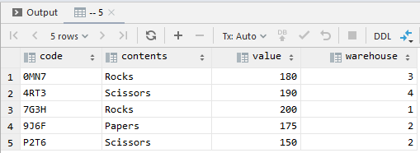

#6

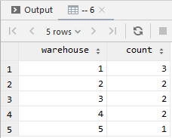

#7

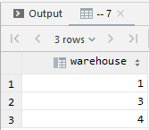

#8

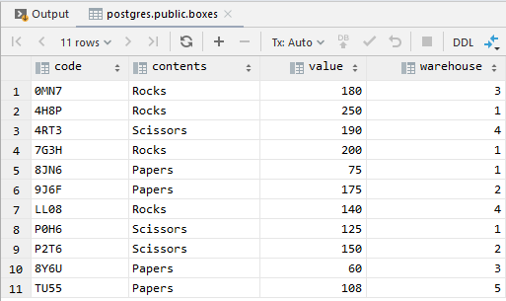

#9

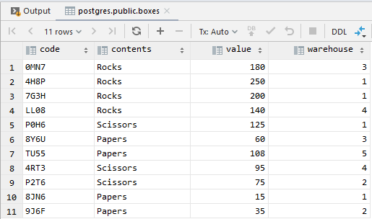

#10

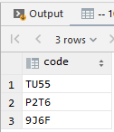

# 11

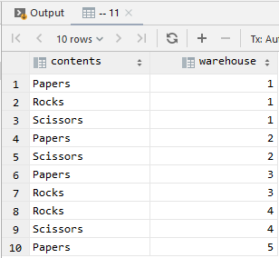

#12

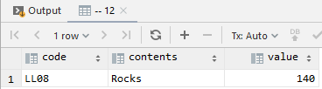

#13

